🟢 Bandit Level 10 → Level 11
The password is in data.txt, but it is Base64 encoded.
Step 1: Check the file
ls
You should see:
data.txt

Step 2: Decode it
To decode it I used base64 to view encoded data to decode
base64 -d data.txt is used
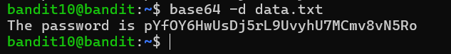
Or else
Use cat data.txt | base64 -d
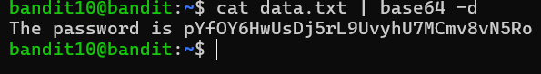
You'll get the password for bandit11 🔑
Then exit from that level

